Design and Development of a Web-Based Information System for Traditional Balinese Decoration Rental
I Putu Dody Suarnatha^{1*}, Putu Gede Surya Cipta Nugraha²
¹Program Studi Sains Informasi, Universitas Hindu Negeri I Gusti Bagus Sugriwa Denpasar, Indonesia
²Program Studi Informatika, Universitas Hindu Negeri I Gusti Bagus Sugriwa Denpasar, Indonesia
Email: iputudodysuarnatha@gmail.com^{1*}, surya.cipta@uhnsugriwa.ac.id²
*Korespondensi penulis: iputudodysuarnatha@gmail.com¹

Abstract. In the current digital era, the use of efficient information systems is essential to improve service quality, including in the decoration rental business. Jr. Dekorasi, a provider of traditional Balinese decorations, still uses manual methods for managing information and transactions, which often leads to delays and errors. This study aims to design and develop a web-based decoration rental information system using native PHP to enhance operational effectiveness and efficiency. The system is developed using the Waterfall method, which includes the stages of requirements analysis, design, implementation, and testing. This system provides features such as decoration information, an online rental form, and data management by the administrator. MySQL is used as the database, and the interface is designed to be user-friendly across various devices. The implementation results show that the system is capable of accelerating service processes, facilitating rental transactions, and supporting centralized data management. This system is expected to become a digital solution that helps Jr. Dekorasi compete in the technological era.

Keywords: Information System, Decoration Rental, Balinese Custom, PHP Native, Website.

- INTRODUCTION
In the modern era, the wedding and event industry in Indonesia has experienced significant growth, with an increasing number of people organizing special celebrations to commemorate important moments. One of the key elements in event planning is decoration, which not only enhances the atmosphere but also reflects the theme and style desired by the event organizers. Bali, as a renowned tourist destination known for its natural beauty and rich culture, has become a significant source of inspiration in decoration design for weddings and other important events in Indonesia. Balinese decoration rentals have become a popular choice among event organizers who seek an exotic and traditional ambiance, ranging from distinctive floral arrangements to traditional ornaments such as penjor, statues of deities, and unique textile motifs. Balinese-style decorations offer a profound visual experience for guests and make the occasion truly unforgettable (Suarmawan et al., 2022)
Jr. Dekorasi, as a business that provides traditional Balinese decoration services, faces challenges in delivering complete information about decoration packages and managing rental operations. These issues arise due to the continued use of conventional methods, such as manual communication via phone calls or text messages, which are often ineffective and prone to errors (Helmina et al., 2023). Incomplete or unstructured information delivery can lead to customer confusion, thereby affecting satisfaction. Additionally, the management of decoration rentals, which is still carried out manually—such as recording transactions—can result in operational inefficiencies. This may lead to overlapping schedules, errors in decoration delivery, or even the loss of important data. (Erika, 2023).
Based on these issues, a solution is needed to help Jr. Dekorasi overcome these challenges. The development of a web-based information system can serve as an effective solution to improve the efficiency of delivering decoration package information and managing rental operations. This system can provide comprehensive information about decoration packages, including prices, types of decorations, and visual examples, allowing customers to easily understand the available options (Lende et al., 2024). In addition, the system can automate rental management processes, such as transaction recording and scheduling, thereby reducing the risk of errors and increasing productivity (Utama et al., 2024).
With the implementation of an integrated information system, Jr. Dekorasi is expected to improve service quality, accelerate business processes, and provide a better experience for customers (Setiawati & Istigfarin, 2023). This will not only enhance customer satisfaction but also help the business compete in the increasingly growing traditional Balinese decoration industry.
Based on the problems that have been described, the author decided to develop a web-based information system for renting traditional Balinese decorations at Jr. Dekorasi using native PHP. Thus, the system is expected to address issues related to delivering information to the wider public, while also assisting customers in obtaining information about available decorations. In addition, it helps the business owner manage data related to decorations, rentals, and customers more effectively (Nur Hanifah & Sutarman, 2025).

- LITERATURE REVIEW
Information System
An information system is a system within an organization that accommodates the needs of daily transaction processing (Ngongo et al., 2026). It supports the organization’s operational functions, particularly those of a managerial nature, as well as its strategic activities, in order to provide reports required by certain external parties (Safira Armah & Rayyan Firdaus, 2024).
Website
A website is a collection of web pages that are interconnected and share related topics, often equipped with files such as images, videos, or other media. A website is a set of web pages that have been published on the internet and have a domain or URL (Uniform Resource Locator) that can be accessed by all internet users by entering its address (Rahmawati et al., 2021).
- RESEARCH METHOD
Method Of Collecting Data
This study uses several data collection methods. The following are the methods along with their explanations:
- Observation
Observation is an activity of examining an object with the aim of obtaining the information needed for research. In this study, the object is Jr. Dekorasi, where the researcher conducted direct visits to gather the required information, which is then used as research data (Ariadi et al., 2025).
- Interview
Interviews are conducted to complement the observational data. An interview is a question-and-answer process between the researcher and the informant to obtain the necessary information. The researcher directly interviewed the owner of Jr. Dekorasi by asking questions related to what information should be displayed in the system and how the decoration rental process takes place (Hafiz & Ma’mur, 2018).
- Literature Study
A literature study is a method of reviewing various sources, including journals, reports, books, and electronic sources. This method is used to gain an overview of the system to be developed. Therefore, data and information are collected by reviewing journals or reports related to the research being conducted. (Sarwono & Nawawi, 2025)
Software Development Methods
In general, an overview of the research methodology can be seen in Figure 1. The stages of this study are based on the software development process using the Waterfall method (Khairunnisa Ramadhanti et al., 2025). In this research method, several stages are carried out to design and develop a web-based information system for renting traditional Balinese decorations.
Figure 1. Research Methodology Using The Waterfall Method.
The initial stage involves gathering information to understand the requirements of a web-based decoration rental system. This includes identifying key features that must be available, such as rental management, decoration selection, payment processes, and system requirements from different users, including customers, administrators, and business owners.
The next step is system design. This includes designing the database to store data related to decorations, customers, and transactions. In addition, the user interface (UI/UX) is designed to ensure that the website is easy and comfortable to use. At this stage, process flow diagrams and data structures are created to ensure the system workflow is clear and well-organized (Hidayat et al., 2022).
The following stage is development. Once the design is complete, the system begins to be built. In this phase, the design is translated into program code. The website is developed using native PHP for data processing and MySQL for database management. Key features, such as selecting decorations, recording transactions, and managing user accounts, are implemented during this stage (Yusuf Anshar et al., 2025).
After development, the next stage is testing. Once the system is built, it is tested to ensure that all components function properly. Testing includes verifying that key features run smoothly (such as checking decoration availability and booking), evaluating system security, and assessing website performance to ensure optimal operation (Mamluah & Nurdiawan, 2023). The user interface is also tested to ensure it is intuitive.
The next stage is implementation. After testing is completed, the system is ready to be used. At this stage, the website is deployed on a server and begins to be used by users (Hermansyah et al., 2023). Business owners and administrators are trained to manage the system, while customers can start renting decorations through the ready-to-use website.
The final stage is maintenance. Once the system is operational, maintenance begins. This includes fixing bugs or other technical issues that may arise, as well as adding new features based on user feedback (Mulyanto et al., 2021). The system is also updated to keep up with evolving market needs and technological developments.
Functional Requirements Analysis
Based on the results of observations and interviews regarding the identified problems, the system’s functional requirements are defined. It is determined that there are two types of users involved in managing the rental of traditional Balinese decorations, namely users (customers) and administrators. The summary of functional requirements for users can be seen in Table 1, while those for administrators are shown in Table 2.

Table 1. Functional requirements of users.
No | Requirement | Objective
1 | Jr. Dekorasi Information | The website must be able to display all information about Jr. Dekorasi, such as company profile, history, organizational structure, service information, facilities, activity gallery, address and contact details, as well as information about the decorations available for rent.
2 | Decoration Rental Form | The website must be able to handle decoration rental processes, allowing users to rent decorations through the provided online form.
3 | Decoration Rental Status Information | The website must be able to display the history of rented decorations, where users can view the status of their decoration rentals.
4 | Automated Messaging Using API (Application Programming Interface) | The website needs to be equipped with an automated messaging feature for both users and administrators. Users will receive notifications containing details of the rented decorations, while administrators will receive automatic messages with information about the renter and the ordered decorations. This feature is expected to accelerate responses to incoming rental requests, thereby minimizing the risk of delays in the follow-up process..

Table 2. Functional requirements of administrators.
No | Requirement | Objective
1 | Authentication | The website must provide an authentication feature to restrict access to the system. This authentication takes the form of a login system that requires users to enter a username and password.
2 | Manage Rental Data | The website must be able to handle rental data management, where the admin can confirm rentals once the user has completed the payment.
3 | Manage Decoration Data | The website must be able to handle decoration data management, allowing the admin to view, add, edit, and delete decoration data.
4 | Manage Gallery Data | The website must be able to handle gallery data management, allowing the admin to view, add, edit, and delete gallery data
5 | Admin Data Information | The website must be able to manage admin data, where the admin can view and update their information.

System Design
The figure below illustrates the design of an Entity Relationship Diagram (ERD), which is a step in database design that describes the interactions between entities in an information system. An ERD helps in structuring the database by showing entities, attributes, and the relationships between them (Syafruddin Akbar & Haryanti, 2021). The stages involved include identifying entities, determining their attributes, defining relationships between entities, and establishing primary keys and foreign keys. The purpose of designing an ERD is to provide a clear overview of the data structure and the relationships among system elements, so that it can be effectively implemented in a database.
Figure 2. Entity Relationship Diagram (ERD).
In Figure 2 above, the Entity Relationship Diagram (ERD) for the design and development of the traditional Balinese decoration rental information system at Jr. Dekorasi illustrates the relationships between entities in the database as follows:
- User and Sewa (Rental)
The User entity is related to the Sewa (rental) entity, where a user can make more than one decoration rental request. This relationship is one-to-many (one-to-many), meaning a single user can rent multiple decorations.
- Sewa (Rental) and Dekorasi (Decoration)
The Sewa entity is connected to the Dekorasi entity, where each rental request is associated with only one decoration rented by the user. This relationship is one-to-one (one-to-one), indicating that one rental transaction involves only one decoration.
- Admin and Sewa (Rental)
The Admin entity is related to the Sewa entity, where the admin is responsible for verifying and approving rental requests from users. This relationship is one-to-many (one-to-many), meaning one admin can handle multiple rental transactions.
- Admin and Dekorasi (Decoration)
The Admin entity is also related to the Dekorasi entity, where the admin is responsible for managing the decorations available for rent. This relationship is one-to-many (one-to-many), meaning one admin can manage and maintain multiple decorations.
User Interface Design
Based on the results of the ERD design, the next step is to design the interface for each functional requirement that has been defined. The homepage interface design can be seen in the figure below.
Customer User Interface Design
On the homepage, information such as the address, operating hours, social media, services, facilities, rental decorations, and gallery will be displayed. The design of the homepage can be seen in the following figure:
Figure 3. Homepage User Interface Display.
In the design of the user interface for the “About Decoration” page, information such as the profile, history, and organizational structure of the decoration business will be displayed. The design of this page can be seen in the following figure:
Figure 4. About User Interface Display.
In the user interface design for the decoration rental page, information such as the decorations available for rent by Jr. Dekorasi will be displayed. The design of this rental page can be seen in the following figure:
Figure 5. Decoration Rental Page Display.
In the user interface design for the decoration detail page, detailed information about the decoration will be displayed, such as images, rental price, stock, included items, and other relevant details. The design of this detail page can be seen in the following figure:
Figure 6. User Interface Display of the Decoration Detail Page.
In the user interface design for the contact page, information such as the address, social media, and phone number will be displayed. The design of this contact page can be seen in the following figure:
Figure 7. User Interface Display of the Contact Page.
In the user interface design for the rental form page, fields will be provided for entering personal data as well as information about the decorations being rented. The design of this rental form page can be seen in the following figure:
Figure 8. User Interface Display of the Rental Form Page.

Admin User Interface Design
The user interface design specifically for the admin is created to design pages that can only be accessed by the administrator. This design provides an initial illustration of the layout structure as well as information related to decorations that can be managed by the admin before entering the website development stage. The following is a visualization of the design:
The user interface design for the admin login page includes input fields for the username and password used by the administrator to access the system. The design of the admin login page can be seen in the figure below:
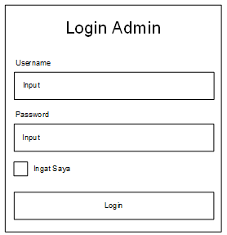
Figure 9. User Interface Display of the Admin Login Page.
he user interface design for the admin data page is intended as a template for all pages that display information in the form of data. The information will be presented in a table format to make it easier to manage and read. The design of the admin data page can be seen in the following illustration:
Figure 10. User Interface Display of the Admin Data Page.

- RESULTS AND DISCUSSION
User Interface (UI) Implementation Results
The results of this interface implementation represent the realization of the user interface design described in the previous chapter. This implementation showcases the website’s interface, which displays information or data related to the research object. The implementation results are divided into two parts: the user interface implementation for the main pages and the user interface implementation for the admin pages.
Based on the user interface design for the homepage, the following is the implementation result of that design.
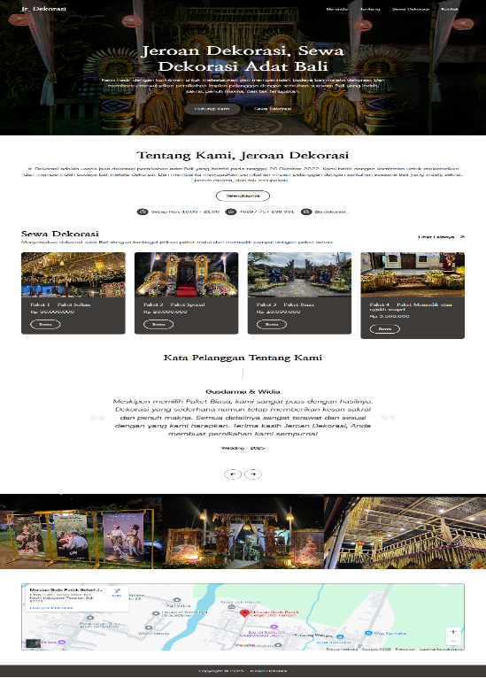
Figure 11. Home Page User Interface Implementation Results.
Based on the user interface design for the “About” page, the following is the implementation result of that design.
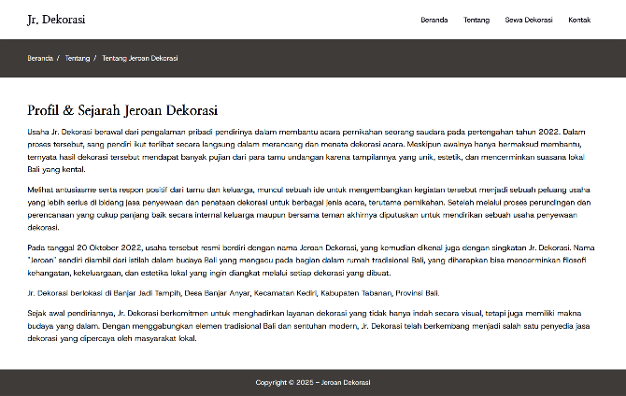
Figure 12. About Page User Interface Implementation Results.
Based on the user interface design for the decoration rental page, the following is the implementation result of that design.
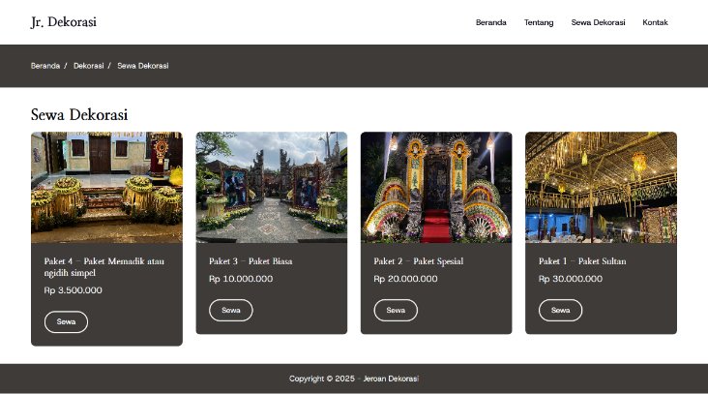
Figure 13. Decoration Rental Page User Interface Implementation Results.
Based on the user interface design for the decoration detail page, the following is the implementation result of that design.
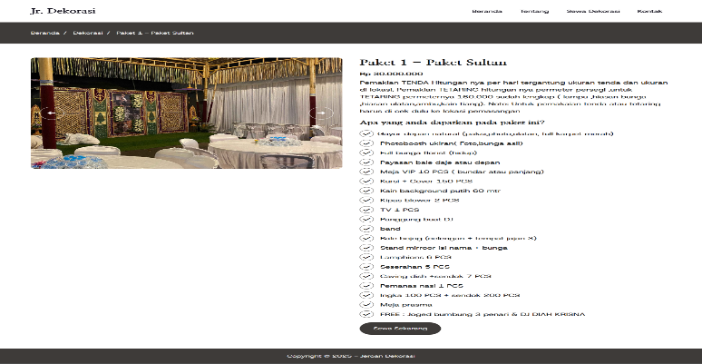
Figure 14. Decoration Detail Page User Interface Implementation Results.
Based on the user interface design for the contact page, the following is the implementation result of that design.
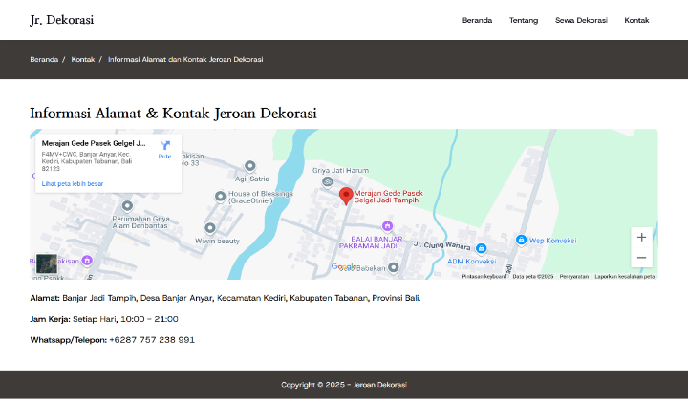
Figure 15. Contact Page User Interface Implementation Results.
Based on the user interface design for the contact page, the following is the implementation result of that design.
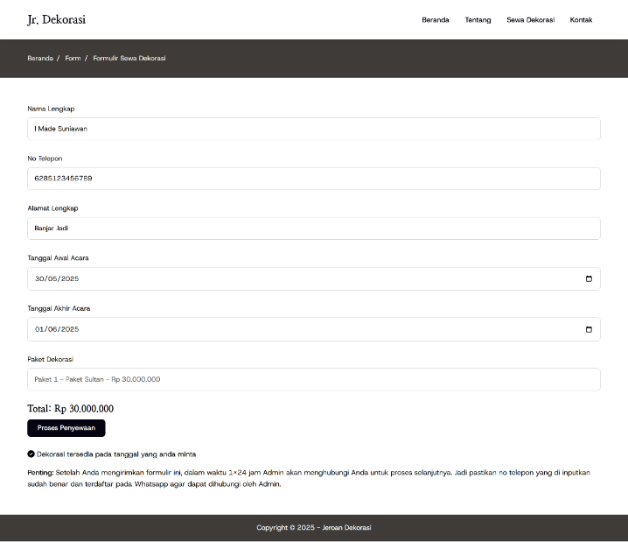
Figure 16. Decoration Rental Form Page User Interface Implementation Results.

Result of Admin Page User Interface Implementation
The implementation results of the admin page user interface are derived from the user interface design for the admin pages presented in the previous chapter. The following are the results of the user interface implementation for the main pages of the website:
Based on the user interface design for the login page, the following is the implementation result of that design.
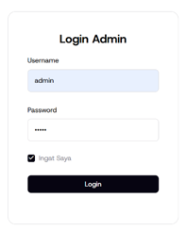
Figure 17. User Interface Implementation Results of the Login Page.
Based on the user interface design for the admin form page, the following is the implementation result of that design for the admin account update page. On the admin page, a submenu is available where the administrator can add information related to rental data, decoration data, and gallery data.
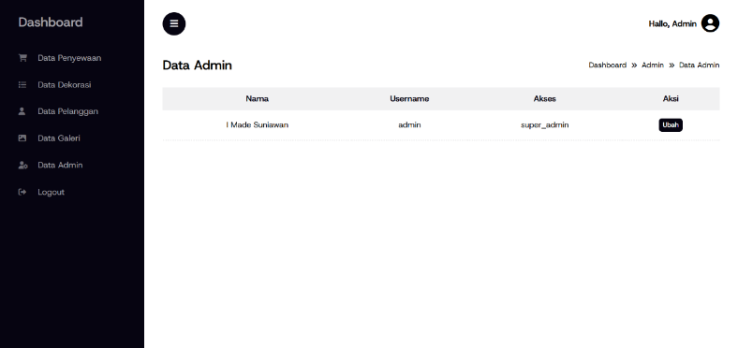
Figure 18. User Interface Implementation Results of the Rental Data Page.
System Testing Results
System testing was conducted using the black box testing method. In this testing, the error guessing technique was applied to detect potential errors based on experience and understanding of the system being tested. The results of the system testing are divided into two parts: the main website pages and the admin pages.
Main Page System Testing Results
The testing results for the main pages include testing the functions available on the website’s main pages, with the aim of ensuring that all features operate properly. The following are the results of the testing that has been carried out:

Table 3. Results of the testing that has been carried out.
No | Testing Scenario | Predicted Error | Expected Result | Test Result
Homepage Testing Results
1 | Click each menu on the main navigation (Home, About, Decoration Rental, Contact) | Menu does not function or does not lead to the correct page | All menus should be clickable and direct to the correct page according to the selection | Valid
2 | User clicks the “Contact Us” button | Button does not function or does not lead to the correct page | The button should function and direct to the correct page | Valid
3 | User clicks the “Rent Decoration” button | Button does not function or does not lead to the decoration rental page | The button should function and direct to the decoration rental page | Valid
4 | User clicks the “Read More” button | Button does not function or does not lead to the About page | The button should function and direct to the About page | Valid
5 | User clicks the “Rent” button on decoration rental | Button does not function or does not lead to the rental form page | The button should function and direct to the decoration rental form page | Valid
Decoration Rental Page Testing Results
6 | User clicks the decoration title | Link does not function or does not lead to the decoration detail page | The link should function and direct to the decoration detail page | Valid
7 | User clicks the “Rent” button | Button does not function or does not lead to the rental form page | The button should function and direct to the decoration rental form page | Valid
Decoration Detail Page Testing Results
8 | User clicks the “Rent Now” button | Button does not function or does not lead to the rental form page | The button should function and direct to the decoration rental form page | Valid
Decoration Rental Form Page Testing Results
9 | User does not fill in all required inputs and then clicks the “Process Order” button | The form is still processed but the stored data is empty | The user should remain on the page and a message should appear prompting them to complete all required inputs | Valid

- CONCLUSIONS AND SUGGESTIONS
Berdasarkan hasil penelitian dan pengembangan sistem informasi penyewaan dekorasi adat Bali pada Jr. Dekorasi, dapat disimpulkan bahwa sistem berbasis website yang dibangun menggunakan PHP Native dengan dukungan MySQL telah berhasil memenuhi kebutuhan pengguna dan admin dalam proses penyewaan dekorasi. Sistem ini dilengkapi dengan berbagai fitur seperti informasi dekorasi, formulir penyewaan, riwayat transaksi, serta notifikasi otomatis yang memudahkan interaksi antara pelanggan dan pengelola, sementara bagi admin tersedia fitur manajemen data dekorasi, galeri, penyewaan, dan akun yang sebelumnya dilakukan secara manual. Penerapan sistem ini terbukti mampu meningkatkan efisiensi, akurasi, dan produktivitas operasional serta memberikan pelayanan yang lebih baik kepada pelanggan. Untuk pengembangan selanjutnya, disarankan agar sistem dilengkapi dengan fitur pembayaran online guna mempermudah transaksi, dioptimalkan agar lebih responsif pada berbagai perangkat khususnya mobile, diintegrasikan dengan media sosial untuk memperluas jangkauan promosi, serta dilakukan pengujian dan pemeliharaan secara berkala guna menjaga stabilitas sistem dan keamanan data.

REFERENCES
Ariadi, F., Andrian, T., & Prasetyo, A. B. (2025). IMPLEMENTASI SISTEM PENDUKUNG KEPUTUSAN PENERIMAAN KARYAWAN BERBASIS WEB MENGGUNAKAN METODE SIMPLE ADDITIVE WEIGHTING PADA INDONESIAN SMART ROBOT. In Jurnal Mahasiswa Teknik Informatika) (Vol. 9, Number 5).
Erika, W. (2023). Rancang Bangun Web Profil Wedding Decoration Sebagai Media Promosi Berbasis Web (Studi Kasus: Chudalla Decoration). JURNAL MAHAJANA INFORMASI, 8(2), 108–111. http://e-journal.sari-mutiara.ac.id/index.php/7
Hafiz, A., & Ma’mur, M. (2018). SISTEM PENDUKUNG KEPUTUSAN PEMILIHAN KARYAWAN TERBAIK DENGAN PENDEKATAN WEIGHTED PRODUCT (Studi Kasus:PT. Telkom Cab. Lampung). Jurnal Cendikia, 23–28.
Helmina, A., Irfan, D., & Effendi, H. (2023). Rancang Bangun Sistem Informasi Berbasis Web di SMK N 1 Ranah Batahan. JAVIT : Jurnal Vokasi Informatika, 64–71. https://doi.org/10.24036/javit.v3i2.140
Hermansyah, Farta Wijaya, R., & Budi Utomo, R. (2023). Metode Waterfall Dalam Rancang Bangun Sistem Informasi Manajemen Kegiatan Masjid Berbasis Web. KLIK: Kajian Ilmiah Informatika Dan Komputer, 3(5), 563–571. https://djournals.com/klik
Hidayat, R., Satriansyah, A., & Nurhayati, M. S. (2022). Penggunaan Metode Waterfall untuk Rancangan Bangun Aplikasi Penyewaan Lapangan Olahraga. BIOS : Jurnal Teknologi Informasi Dan Rekayasa Komputer, 3(1), 9–16. https://doi.org/10.37148/bios.v3i1.35
Khairunnisa Ramadhanti, N., Fajarwati, D., Listyaningsih, U., Septiyanti, N. D., & Basatha, R. (2025). Rancang Bangun Aplikasi Presensi Siswa (PRESIS) Berbasis Desktop menggunakan Metode Waterfall. Jurnal Teknologi Pendidikan Dan Pembelajaran (JTPP), 3(2), 407–418.
Lende, K., Umar, E., & Ayu, M. P. (2024). Sistem Informasi Penyewaan Jasa Dekorasi Berbasis Web Studi Kasus (Helen Dekorasi). Jurnal Ilmu Komputer Dan Informatika, 1, 27.
Mamluah, K., & Nurdiawan, O. (2023). RANCANG BANGUN APLIKASI PENGGAJIAN BERBASIS WEB MENGGUNAKAN METODE WATERFALL. JATI (Jurnal Mahasiswa Teknik Informatika), 7(1).
Mulyanto, A., Aulia, S., Salam, F., Kapten, J., Nomor, S., Utara, C., & Bekasi, K. (2021). PENERAPAN METODE WATERFALL PADA APLIKASI TOKO ONLINE BIMA KIRANA CIBITUNG. JURNAL ILMIAH TEKNOLOGI INFORMASI DAN KOMUNIKASI (JTIK), 12(2), 34–41. http://ejurnal.provisi.ac.id/index.php/JTIKP
Ngongo, A., Yulius Nahak Tetik, & Mitra Permata Ayu. (2026). Rancang Bangun Sistem Informasi Akademik Berbasis Web. Merkurius : Jurnal Riset Sistem Informasi Dan Teknik Informatika, 4(1), 14–33. https://doi.org/10.61132/merkurius.v4i1.1271
Nur Hanifah, A., & Sutarman. (2025). Pengembangan Sistem Booking Tenda dan Dekorasi Online Menggunakan Metode Waterfall dengan Integrasi Pembayaran Digital. BULLETIN OF COMPUTER SCIENCE RESEARCH, 6(1), 163–174. https://doi.org/10.47065/bulletincsr.v6i1.848
Rahmawati, E., Purnomo, A. A., & Nuryadi, N. (2021). RANCANG BANGUN SISTEM INFORMASI BERBASIS WEB PADASMK MADANI DEPOK MENGGUNAKAN FRAMEWORKCODEIGNITER. Jurnal Rekayasa Perangkat Lunak, 2(Mei). http://jurnal.bsi.ac.id/index.php/reputasi5
Safira Armah, & Rayyan Firdaus. (2024). Konsep Dan Penerapan Sistem Informasi Manajemen. Jurnal Inovasi Manajemen, Kewirausahaan, Bisnis Dan Digital, 1(3), 50–56. https://doi.org/10.61132/jimakebidi.v1i3.192
Sarwono, & Nawawi, H. M. (2025). Sistem Pendukung Keputusan Pemilihan Supplier Menggunakan Metode SAW pada PT. Medikaloka Manajemen. Jurnal Sistem Komputer Dan Kecerdasan Buatan, 18–27.
Setiawati, T., & Istigfarin, R. (2023). Rancang Bangun Sistem Informasi Pendapatan Atas Jasa Penyewaan Dekorasi Wedding Pada Rayainaja Decoration. Journal of Accounting Information System, 3(1). http://jurnal.bsi.ac.id/index.php/jais20
Suarmawan, P. Y., Koriawan, G. E. H., & Rediasa, I. N. (2022). PEMBUATAN DEKORASI RUMAH PENGANTIN DI DWIKA DEKORASI DESA SELAT, BULELENG, BALI. Jurnal Pendidikan Seni Rupa Undiksha, 12(3), 192–198. https://ejournal.undiksha.ac.id/index.php/JJPSP/index
Syafruddin Akbar, I., & Haryanti, T. (2021). PENGEMBANGAN ENTITY RELATIONSHIP DIAGRAM DATABASE TOKO ONLINE IRA SURABAYA. Jurnal Ilmiah Computing Insight, 3(2), 28.
Utama, I. P. A. S., Wijaya, I. N. Y. A., & Putra, A. A. G. A. M. (2024). Rancang Bangun Sistem Informasi Manajemen Berbasis Website di PT Bali Tresna Cemerlang dengan Metode Prototype. Jurnal Sosial Dan Teknologi (SOSTECH), 4, 548–565.
Yusuf Anshar, M., Andhika Kurniawan, M., & Adi Umarotussalam, R. (2025). Seminar Nasional Informatika Bela Negara (SANTIKA) Rancang Bangun Aplikasi Web Profil untuk UMKM Aquavita II Menggunakan Model Waterfall. Seminar Nasional Informatika Bela Negara (SANTIKA), 5, 1–9.

